LAB SHEET – 4
Title: Implementation of User Creation, Deletion, and Privilege Management in SQL
Problem Statement: Design and execute SQL commands to create users, manage their access privileges, and remove users in a database system. This assignment focuses on database security and access control mechanisms.
Database security ensures that only authorized users can access or modify data. MySQL provides commands such as:
- CREATE USER → to create new users
- GRANT → to give permissions
- REVOKE → to remove permissions
- DROP USER → to delete users
Privileges include:
- SELECT (read data)
- INSERT (add data)
- UPDATE (modify data)
- DELETE (remove data)
Step 1: Create Database and Tables


Explanation:
- Creates a database named LAB_SHEET_4
- Selects it for further operations
Create Tables
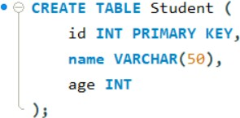

Explanation:
Creates a Student table where:
- id is unique
- name stores student name
- age stores age
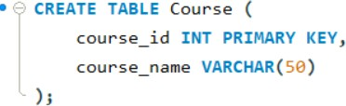

Explanation:
Creates a Course table to store course details.

Part A: User Creation
Step 2: Create user1

Explanation:
- Creates a user named user1
- 'localhost' means user can log in from same system
- IDENTIFIED BY sets password
Step 3: Create user2

Explanation:
Creates another user user2 with login credentials.

Part B: Granting Privileges
Step 4: Grant SELECT and INSERT to user1

Explanation:
- SELECT → allows viewing data
- INSERT → allows adding data
- Access is limited to Student table only
Step 5: Grant ALL privileges to user2

Explanation:
- Gives full access (SELECT, INSERT, UPDATE, DELETE, etc.)
- Only on Course table
Step 6: WITH GRANT OPTION

Explanation:
- Allows user1 to give permissions to other users
- This is called privilege delegation

Part C: Revoking Privileges
Step 7: Revoke INSERT from user1

Explanation:
- Removes only INSERT permission
- user1 can now only read data
Step 8: Revoke ALL from user2

Explanation:
- Removes all permissions
- user2 cannot access Course table anymore

Part D: User Deletion
Step G: Drop user2

Explanation:
- Permanently deletes the user
- All privileges are removed
Step 10: Show all users

Output:
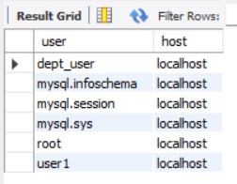

Explanation:
Displays all users present in MySQL system.
Step 11: Show privileges of user1

Output:
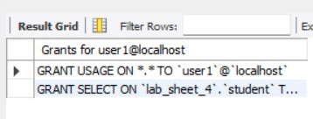
Explanation:
Displays all permissions assigned to user1.

